C450-1 Integer Pointers Program
Ethan Yang
Course: C450-1
Integer Pointers Program
Pseudocode
Start program
Create three integer variables
Ask the user to enter the first integer
Store the first integer in the first variable
Ask the user to enter the second integer
Store the second integer in the second variable
Ask the user to enter the third integer
Store the third integer in the third variable
Create three integer pointers using dynamic memory
Store each variable’s value into its own dynamic memory location
Display the original variable values
Display the pointer memory addresses
Display the values stored in the pointer memory locations
Use delete to free the dynamic memory
Set each pointer to nullptr
End program
Source Code
#include <iostream>
using namespace std;
int main()
{
int numberOne;
int numberTwo;
int numberThree;
cout << "Integer Pointers Program" << endl;
cout << endl;
cout << "Enter the first integer: ";
cin >> numberOne;
cout << "Enter the second integer: ";
cin >> numberTwo;
cout << "Enter the third integer: ";
cin >> numberThree;
int* pointerOne = new int;
int* pointerTwo = new int;
int* pointerThree = new int;
*pointerOne = numberOne;
*pointerTwo = numberTwo;
*pointerThree = numberThree;
cout << endl;
cout << "Original Variable Values" << endl;
cout << "numberOne: " << numberOne << endl;
cout << "numberTwo: " << numberTwo << endl;
cout << "numberThree: " << numberThree << endl;
cout << endl;
cout << "Pointer Memory Addresses" << endl;
cout << "pointerOne address: " << pointerOne << endl;
cout << "pointerTwo address: " << pointerTwo << endl;
cout << "pointerThree address: " << pointerThree << endl;
cout << endl;
cout << "Values Stored in Dynamic Memory" << endl;
cout << "Value pointed to by pointerOne: " << *pointerOne << endl;
cout << "Value pointed to by pointerTwo: " << *pointerTwo << endl;
cout << "Value pointed to by pointerThree: " << *pointerThree << endl;
delete pointerOne;
delete pointerTwo;
delete pointerThree;
pointerOne = nullptr;
pointerTwo = nullptr;
pointerThree = nullptr;
cout << endl;
cout << "Dynamic memory has been released." << endl;
cout << "Program complete." << endl;
return 0;
}
Example Output
Integer Pointers Program
Enter the first integer: 10
Enter the second integer: 25
Enter the third integer: 50
Original Variable Values
numberOne: 10
numberTwo: 25
numberThree: 50
Pointer Memory Addresses
pointerOne address: 0x600001234010
pointerTwo address: 0x600001234020
pointerThree address: 0x600001234030
Values Stored in Dynamic Memory
Value pointed to by pointerOne: 10
Value pointed to by pointerTwo: 25
Value pointed to by pointerThree: 50
Dynamic memory has been released.
Program complete.
Explanation
For this assignment, I created a C++ console application that asks the user to enter three integer values. The values are first stored in three regular integer variables. Then, I created three integer pointers using the new operator. Each pointer points to a separate location in dynamic memory.
The program stores the user’s values inside the dynamic memory locations by using the dereference operator. It then displays the original variable values, the pointer memory addresses, and the values stored in dynamic memory. At the end of the program, the delete operator is used to release the memory that was created with new. Each pointer is then set to nullptr to help prevent accidental use of a pointer after the memory has been released.
This program demonstrates basic C++ concepts such as variables, user input, output, pointers, dynamic memory allocation, dereferencing, and memory management.
Screenshots
Screenshot 1: Program Source Code
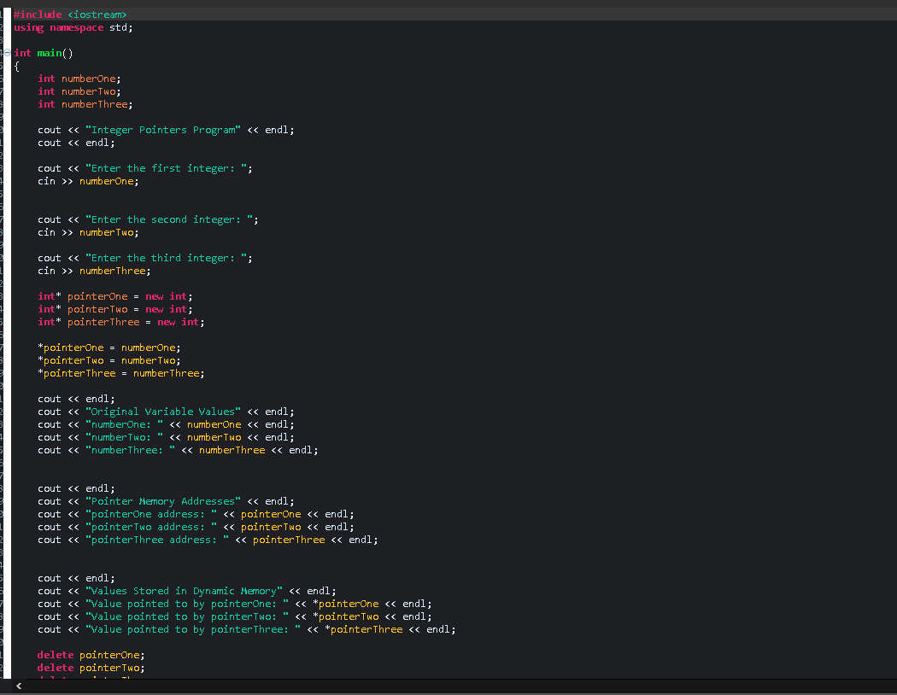
Screenshot 2: Program Running\ Program Results
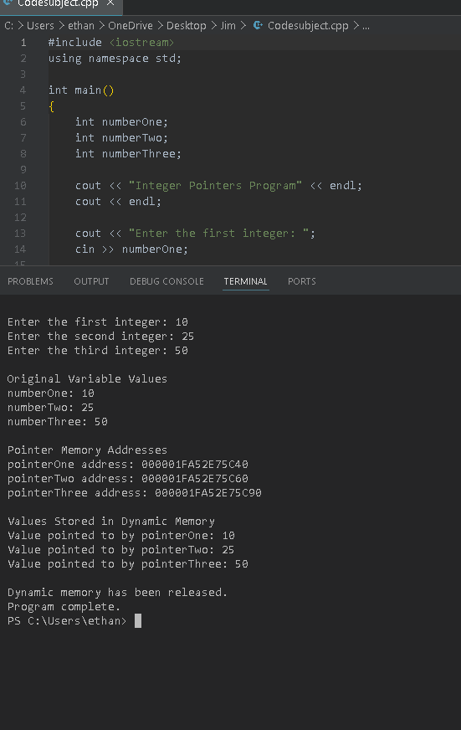
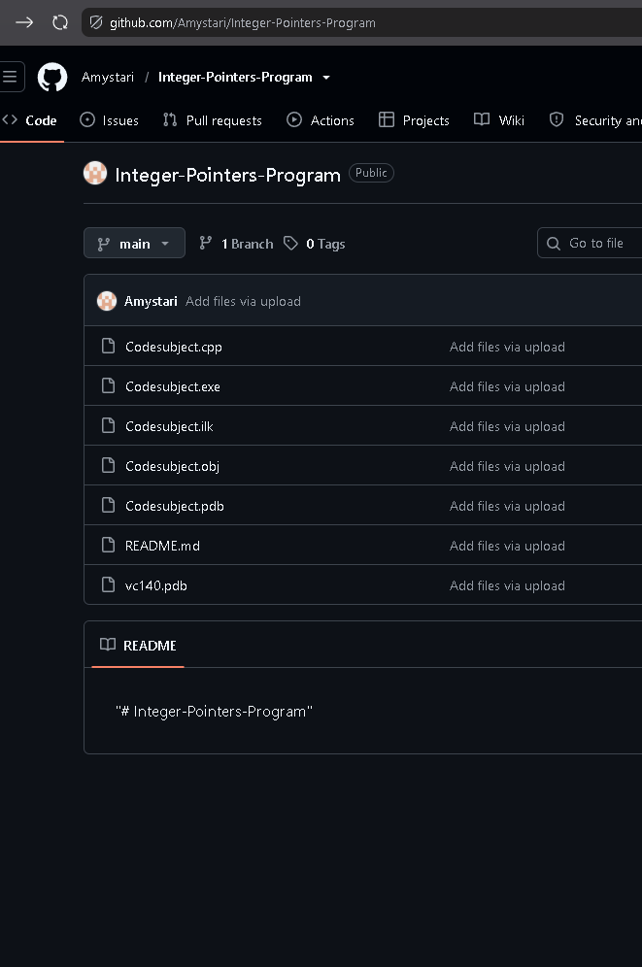
Reflection
This assignment helped me practice using pointers and dynamic memory in C++. I learned how to create memory with the new operator, store values in that memory, access the values with pointers, and release the memory with the delete operator. This is important because C++ gives the programmer more control over memory, but it also requires careful memory management to avoid errors.

